Ghulam Shabbir

7 D

AI

Lab task 1

Code:

# a. Create a variable name and assign your name to it.

name = "John"

print(name)

# b. Create variables num1 and num2, assign them integer values, calculate and print their sum.

num1 = 10

num2 = 20

sum_of_nums = num1 + num2

print("Sum:", sum_of_nums)



# a. Create a string variable sentence with the value "Hello, World!".

sentence = "Hello, World!"

# b. Print the length of the string.

print("Length of the string:", len(sentence))

# c. Print the first three characters of the string.

print("First three characters:", sentence[:3])

# a. Create a list fruits with three fruit names.

fruits = ["apple", "banana", "cherry"]

# b. Add a new fruit to the list.

fruits.append("orange")

# c. Print the second item in the list.

print("Second fruit:", fruits[1])

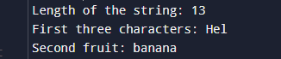

# a. Write a program that takes a number as input and prints whether it's positive, negative, or zero.

num = int(input("Enter a number: "))

if num > 0:

    print("Positive number")

elif num < 0:

    print("Negative number")

else:

    print("Zero")

# b. Write a program to check if a number is even or odd.

num = int(input("Enter a number: "))

if num % 2 == 0:

    print("Even number")

else:

print("Odd number")



# a. Use a loop to print numbers from 1 to 5.

for i in range(1, 6):

    print(i)

# b. Use a loop to iterate through a list of colors and print each color.

colors = ["red", "blue", "green", "yellow"]

for color in colors:

    print(color)

# a. Write a function square that takes a number as input and returns its square.

def square(num):

    return num ** 2

print("Square of 4:", square(4))

# b. Write a function greet that takes a name as input and prints a greeting.

def greet(name):

    print(f"Hello, {name}!")

greet("Alice")

# a. Create a dictionary student with keys 'name' and 'age'.

student = {

    'name': 'John',

    'age': 20

}

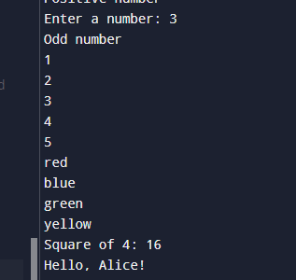

# b. Add a new key-value pair to the dictionary.

student['grade'] = 'A'

# c. Print the value associated with the 'age' key.

print("Student's age:", student['age'])

a. Create a text file and write a few lines of text to it using Python.

import math

num = 16

print("Square root:", math.sqrt(num))

def my_function():

    return "Hello from my module!"

from my_medule import my_function

print(my_function())

Output

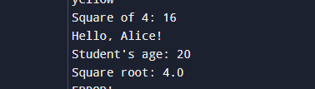

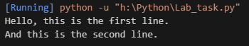Screenshot 2024-10-22 114911